Transistor Motor Control
In this example, when a pushbutton connected to digital pin 2 is pressed, the Arduino will control a transistor via pulse-width modulation (PWM), which will ramp up the motor's speed, then slow it back down.

About Transistors
The Arduino can only provide 40mA at 5V on its digital pins. Most motors require more current and/or voltage to operate. A transistor can act as a digital switch, enabling the Arduino to control loads with higher electrical requirements. The transistor in this example completes the motor's circuit to ground. This example uses a TIP120, which can switch up to 60V at 5A.
When PWMing a transistor, it's similar to pulsing an LED. The higher the PWM value, the faster the motor will spin. The lower the value, the slower it will spin.
Transistors have three pins. For Bipolar Junction Transistors (BJT), like the one used used in this example, the pins are called base, collector, and emitter. A small amount of current on the base pin closes a circuit between the collector and emitter pins. BJTs come in two different types, NPN and PNP. The TIP120 is a NPN-type transistor, which means the collector will connect to the motor, and the emitter will connect to ground.

About Motors
Motors work through a process called induction. When you an put electric charge through wire, a magnetic field is created. A coiled wire will create a stronger field, as will increased current. In a DC motor, a coiled wire surrounds the motor's shaft. The generated magnetic field is pulled and repulsed by magnets inside the motor's body.
When a motor stops, there is the potential for a small amount of current to be generated as the shaft continues spinning. A diode placed in parallel with the motor leads will keep any generated electricity from damaging your circuit.
Motors will pull the most current when they start up, or have a load. The stall current is the amount of current a motor will pull when it is stopped by a force. When a motor is up and running, it will pull significantly less current.
The voltage rating describes the peak operating voltage for a motor, when it works at optimum efficiency. Going over or under the motor's rated voltage will, over time, shorten the motor's life. If you provide less than the rated voltage, the motor will spin more slowly. Typically, a motor needs about 1/2 its rated voltage to run. If you provide less than that when starting up, it probably won't begin to move.

Hardware Required
- Arduino Board
- A momentary switch or button
- 10k ohm resistor
- breadboard
- hook-up wire
- 9V DC motor
- TIP120 transistor
- 1N4001 diode
- 9V battery

Circuit
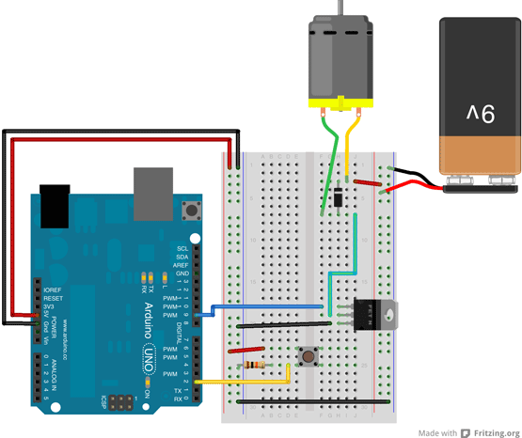
image developed using Fritzing. For more circuit examples, see the Fritzing project page
First, connect wires for power and ground. In the illustration, the red (power) and black (ground), connect to the two long vertical rows on the side of the breadboard. This provides access to the 5 volt supply and ground.
Place the pushbutton on the breadboard, straddling the center. A wire connects digital pin 2 to one leg of the pushbutton. That same leg of the button connects through a 10-kilohm pull-down resistor to ground. The leg of the button not connected to the Arduino should be wired to the 5 volt supply.
Connect pin 9 on the Arduino to the base pin of the TIP120. If you are looking at the transistor so that the metal tab is facing away from you, the base pin is on the left side of the transistor. This is the pin that will control open or close the . The transistor's collector connects to one lead of the motor, the emitter to ground.
The other end of the motor connects to the positive lead of the 9V battery. Connect the battery's ground to the Arduino's ground.

Schematic
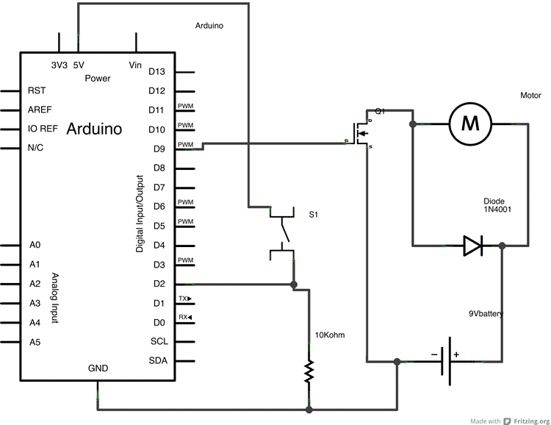

Code
First, create a pair of variables for the pushbutton's state and the motor control pin :
int pushButton = 2;
int motorControl = 9;
In the setup(), declare these pins as an input and output, respectively :
void setup() {
pinMode(pushButton, INPUT);
pinMode(motorControl, OUTPUT);
}
[Get Code]
Now that your setup has been completed, move into the loop().
Read the state of the pushbutton and check if it is HIGH. It's possible to make the evaluation directly in your if()statement like this :
if(digitalRead(pushButton) == HIGH){
If the button is pressed, ramp up the speed of the motor by increasing the PWM value of the motorControl pin. Once it has reached full speed, ramp back down:
for(int x = 0; x <= 255; x+=5){
analogWrite(motorControl, x);
delay(50);
}
for(int x = 255; x >= 0; x-=5){
analogWrite(motorControl, x);
delay(50);
}
[Get Code]
Close the if() statement and add a small delay() before closing the loop().
}
delay(1);
[Get Code]
/*
Motor Control with a Transistor
This example shows you how to control a motor's using a transistor.
When a pushbutton on pin 2 is pressed, the Arduino will control a transistor
via PWM, which will slowly ramp up the motor's speed, then slow it down.
The circuit :
* momentary switch with one end connected to 5V, the other end connected
to GND through a 10-kilohm resistor, and digital pin 2.
* TIP120 tranistor, with the Base connected to digital pin 9, the Emitter to ground,
and the Collector to one lead from a 9V DC motor
* a 9V battery, with the ground connected to the Arduino's ground, and the power
connected to the motor
* 1N4001 diode across the motor's leads, with the striped side conneted to the 9V
The Arduino can only provide 40mA at 5V on its pins. Most motors require
more current and/or voltage to overcome intertia and run. A transistor
can act as a digital switch, enabling the Arduino to control loads with
higher electrical requirements.
*/
// give a name to digital pin 2, which has a pushbutton attached
int pushButton = 2;
// the transistor which controls the motor will be attached to digital pin 9
int motorControl = 9;
// the setup routine runs once when you press reset:
void setup() {
// make the pushbutton's pin an input:
pinMode(pushButton, INPUT);
// make the transistor's pin an output:
pinMode(motorControl, OUTPUT);
}
// the loop routine runs over and over again forever:
void loop() {
// read the state of the button and check if it is pressed
if(digitalRead(pushButton) == HIGH){
// ramp up the motor speed
for(int x = 0; x <= 255; x++){
analogWrite(motorControl, x);
delay(50);
}
// ramp down the motor speed
for(int x = 255; x >= 0; x--){
analogWrite(motorControl, x);
delay(50);
}
}
delay(1); // delay in between reads for stability
}

The voltage drop you are seeing under load is normal for this type of transistor. Internally the TIP120 is actually two transistors, with the Emitter of the first one connected to Base of the second one. In this configuration the total current gain is very high, but the saturation voltage is also quite high (up to 2V at 3A), because it is the sum of the first transistor's Collector-Emitter and second transistor's Base-Emitter junctions.
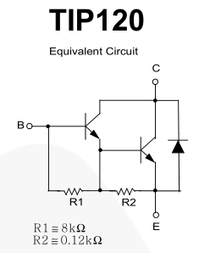
In many circuits this higher voltage drop isn't a problem. However your solenoid valve is only specified to work on 12V +-10%, which means it will just work (or not!) at 10.8V. A device will often still work outside of its specifications, but apparently yours doesn't. Therefore you have 3 options:-
Use a higher voltage power supply (eg. 13.2V) to compensate for the voltage drop in the Darlington transistor.
Replace the TIP120 with a device that has lower voltage drop, eg. a 'Logic Level' power MOSFET.
Use a valve that is specified to work at 10V or less.
Note: Solenoid coils have very high inductance. When switching off this generates a high voltage spike as the magnetic field collapses, which can kill your transistor. To prevent this you should wire a diode (eg 1N4001) across the solenoid, with Cathode to the positive power supply connection so it doesn't normally conduct. Don't get the polarity wrong or the diode will short circuit the solenoid

